Highcliffe School Student Bulletin
Monday 4th – Friday 8th February 2008: Week B

Thought For The Week:

News Topic of the Week:
Bizzare new creature discovered!
‘See http://news.bbc.co.uk/cbbcnews/default.stm

VOTE FOR OMAR ON WEDNESDAY!

On Wednesday, elections to become a member of Dorset’s Youth Parliament will be taking place in school. Omar Sharif in Year 8 is standing alongside candidates from other Dorset schools. All students in the 40 secondary schools in Dorset can vote. Omar has produced a 3 point manifesto and is campaigning for improved skateparks, free or discounted bus travel for young people and a fixed homework timetable.
Please take a moment during break or lunchtime to vote for Omar. Mrs Stone.

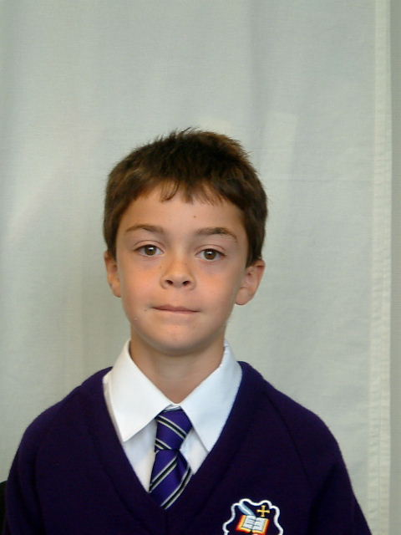
My name is Omar, and I am in 8.5. I am standing for the Dorset Youth Parliament this year, and am the only person from Highcliffe. The Three reasons that I am standing are as follows:
- Structured Homework Timetable
- Improved sports equipment and skateparks
- Free bus travel for under 18’s
The election will take place in this school and in others in the whole of Dorset. If you would like to see these issues come into action, then please vote for Omar!
For more information visit www.dorsetforyou.com/ukyp



YEAR 7 AND 8 VALENTINES DISCO
This will be held on Tuesday 12th February
6:30pm – 8:30pm
Buy tickets for £3.50 outside the performance hall at break time from Tuesday 5th February.
Dedications can be made at a cost of 50p
Refreshments will be on sale.
There will be a prize for the person wearing the most number of red items. This event is being organised by the World Challenge Team who are raising money to fund their trip to India in the summer of 2009.

See you there! The World Challenge Team.

S-FACTOR this Thursday in SC10 3.20pm until 4.15pm. All Years welcome! A spectacular S-Factor for the new term - Make your own Fire Extinguishers & Bath Bombs!

Art, Art Textiles and Photography Exhibition At Highcliffe Castle: Art, Art Textiles and Photography students from Highcliffe School have been selected to exhibit their work at Highcliffe Castle. The exhibition 'Insight' runs from Friday 1st February - Sunday 24th February 11am - 4pm daily and includes a range of exciting work completed by students in Years 7-13. Please join us for the Private View on Tuesday 12th February at 4.30 - 5.30pm at Highcliffe Castle. Thank you for your support.


Mock Interviews: These will be taking place on Tuesday 5th, Wednesday 6th and Thursday 7th February. Students who have taken up this opportunity will find a spreadsheet with times and venues outside the Data and Examinations Office, Student Support Office and with their tutor. Please check carefully and make sure that you arrive promptly for your interview at your designated room.
We are please to welcome into school a number of local people who are giving up their time to help us with this activity. Please make them feel welcome. Mrs. Stone and Mrs. Dedman.

Year 13 Applications to Arts Institute at Bournemouth: Simon Frend, Design Pathway Leader for the Art and Design Foundation Course at the Arts Institute will be visiting Highcliffe on Friday 14th March from 9.30am to 4.00pm to conduct formal interviews for the Art Foundation Course.
The following Year 13 students are involved in interviews in AT11:
Laura Cuppage 9.30am Ria Trudgeon 10.00am
Katie Thomas 10.30am Emma Perry 11.00am
Chloe Newman 11.30am Dominic Burton 12 noon
Lana Williamson 12.30pm Amy Crosley 2.00pm
Michael Garlick 2.30pm Laura Coleman 3.00pm
Roxanne Carr 3.30pm

Duke of Edinburgh: Tuesday 5th February 3:30pm – 4:30pm
This session is on map skills in preparation for the expedition. Everyone participating in the award must attend this meeting. If this is not possible, please see Miss White or Miss Clark. See you there! Miss Clark and Miss White.

Online UK & Ireland Newspaper trial
For the next month we have in school an on-line newspaper trial. This could help you with your research/homework/coursework as it covers all the UK & Irelands newspaper articles that have been printed in the last few years. Please access the site with the username and password provided. Mrs Wheeler in the library would like to know if you think this is a good resource to have in school, please pass your comments on to her.
Web address is http://infoweb.newsbank.com
User name: highcliffe
Password: highcliffe

ECO NEWS
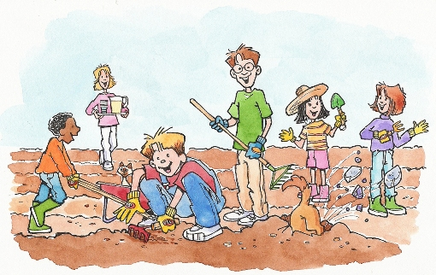
Tuesday after school 'till 4.20pm meet in Sc6
Design the vegetable patch (to be) and plant some broad bean seeds.

Anyone and everyone welcome

Come and be part.................

PE NOTICES
Year 7 Football against Ringwood Drew 0-0
Year 10 Football against Ringwood Won 3-2
Year 7 County Cup Girls Football against Oakdale Lost 1-0
Year 11 Netball against St. Peters Lost 9-8
Year 7 Basketball against St. Peters Won 18-16

MUSIC NOTICES

A number of students are not attending instrument lessons – please remember to attend! If anyone does not know where to go or have any other problems please come to see Mrs Coomber in the Finance Office during tutor time or around school during the day.

SHOUT: after school this Wednesday 6th February 3:30pm - 4:30pm to do a recording for the CD.

The Young Musician Competition takes place this week, an opportunity for students of all abilities to perform on their instruments in front of a small audience and receive positive criticism and feedback from the music staff. The competition culminates in a concert on Thursday 14th February in which the winners from each category perform and an overall winner is decided.

IMPORTANT! Students that have handed in an entry slip will need to arrive promptly at the times listed below ready to perform on their instrument:
Monday p5 - Drums
Tuesday p4 - Guitars
Wednesday p4 - Higher tier Voice
Wednesday p5 - Woodwind/Strings
Friday p3 & p4 - Lower tier Voice
Friday p5 - Keyboard
All sessions are in EX3 except Keyboard, which will be held in EX2

Advanced notice. VOCALIS will now meet the week after half term for an after school recording session for the CD.


BRAINTEASER:
Three consecutive numbers multiplied together give the answer 658416. What are they?

Solutions to be put in the brainteaser box in Ma6 before Friday 15th February.

Last week’s brainteaser
The solution to last week’s brainteaser was: It takes more muscles to smile than to frown.
Well done to the winner, Emma Barry of 8.6!

P.E. FIXTURES/PRACTICES

4th February – 8th February 2008

 | LUNCHTIME | AFTER SCHOOL
Monday | Year 7 football | Year 8 netball v Wentworth (A)  Year 7 County Cup v Dorchester Middle (A)
Tuesday | Year 9 football  Year 10 fitness | Girls football club  Year 9 rugby practice  Year 10/11 fitness club
Wednesday | Year 8 football | Under 15s County Netball Tournament (A)  Year 9 Rugby v Priestlands (H)  Girls rugby club  Years 7 & 8 netball club
Thursday | Years 10 football  Year 11 fitness | Year 8 County Rugby (All Day)  Years 9,10,11 netball club
Friday | Girls basketball

Christchurch Activities for Young People
(CAYP)

A PROGRAMME OF ACTIVITIES FOR YOUNG PEOPLE ACROSS CHRISTCHURCH

This programme is valid from Monday 18th February to Friday 22nd February 2008.

This activity scheme is being offered by the Christchurch Learning Partnership and is hosted by:


The Grange School
Redvers Road
Christchurch
Dorset
BH23 3AU
TEL: 01202 486536 (term time only)


Somerford Primary Community School
Draper Road
Christchurch
Dorset
BH23 3AS
Tel: 01202 485436 (term time only)


The Somerford Children’s Centre
Programme co-ordinator: Jae Harris, Extended Schools Manager
FOR BOOKINGS AND ENQUIRIES TEL: 07785935928

Please complete the booking form and consent form when booking an activity or activities. Separate forms are required per child but one consent form covers all activities. Please make sure payment is enclosed with any booking. Closing date for all bookings is 15th February. There may be additional spaces available for activities after this date but adults are advised to phone 48 hours prior to the activity to check. If you require any further advice or information please contact Jae Harris on the above number.

PROGRAMME OF ACTIVITIES

 |  | MON 18 | TUES 19 | WEDS 20 | THURS 21 | FRI 22
5 – 7  YEAR OLDS | 9.30am – 12.00pm | Art and Craft  Somerford Primary School  32 places  £4.50 | Family day to the PYearamids* water park at Southsea.  Meet at the Somerford Centre at 9.15. Return by 4pm  60 places  £4.00 per person  £1.00 under 1’S | Cooking* for  5 – 10 year olds  The Grange  22 places  £4.50 | Soft play and circus fun for  5 – 10 year olds.  Somerford Primary school  25 Places  £4.50 | Pure Funk  Streetdance  for 5-10 year olds.  Somerford Primary school  32 places  £4.50
8 AND OVERS | 10.00am – 4pm | Splashdown*  Meet at The Grange  48 places  £6.00 |  | 11 years and over *  Three day residential trip to Osmington Bay activity centre in Weymouth. Meet at The Grange at 10.30am Wednesday 20th and return Friday 22nd at approx 3.30pm.  30 places  £35.00

NB * THESE ACTIVITIES NORMALLY GET BOOKED UP QUICKLY SO EARLY BOOKING IS ADVISED.

Liabilities. Dorset County Council can only be held liable for damage, loss or injury if it can be shown that an employee, servant or agent has been negligent by act or omission and that this was the cause of the said damage, loss or injury.

PLEASE NOTE: It is the parent/carers responsibility to arrange for their child/young person to get to and from the activities or the stated meeting points. Lunch, snacks or refreshments are NOT provided and it is the parent/carers responsibility to ensure that their child/young person brings with them any drinks, snacks or lunches they may need for the activity sessions. Also please ensure that all young people are adequately dressed for the activity which they are participating in.

BOOKING FORM

February 18th – 22nd 2008

I would like to book a place / places on the following activities (please tick):

 |  | MON 18 | TUES 19 | WEDS 20 | THURS 21 | FRI 22
5 – 7  YEAR OLDS | 9.30am – 12.00pm | Art and Craft  Somerford Primary School  32 places  £4.50 | Family day to the PYearamids* water park at Southsea.  Meet at the Somerford Centre at 9.15. Return by 4pm  60 places  £4.00 per person  £1.00 under 1’s | Cooking* for  5 – 10 year olds  The Grange  22 places  £4.50 | Soft play and circus fun for  5 – 10 year olds.  Somerford Primary school  25 Places  £4.50 | Pure Funk  Streetdance  for 5-10 year olds.  Somerford Primary school  32 places  £4.50
8 AND OVERS | 10.00am – 4pm | Splashdown*  Meet at The Grange  48 places  £6.00 |  | 11 years and over *  Three day residential trip to Osmington Bay activity centre in Weymouth. Meet at The Grange at 10.30am Wednesday 20th and return Friday 22nd at approx 3.30pm.  30 places  £35.00

I enclose £______________payment for the above ticked activities. (Please make cheques payable to The Grange School).

Please return payment, booking and consent forms to: Jae Harris, Extended Schools Manager, The Grange School, Redvers Road, Christchurch, Dorset, BH23 3AU.

CONSENT FORM

Name of young person:………………………………………………………Date of Birth………………………….

Address ………………………………………………………………………………………………………………..

Telephone Number…………………………………..

School attending:…………………………………………………………….Year group ………………………..

Name and relationship to the young person of emergency contact…………………………………………................

EMERGENCY CONTACT NUMBER………………………………..

Name and telephone number of doctor:……………………………………………………………….……..

Are there any medical or health conditions which may affect the young person whilst participating in the chosen activities? YES / NO
If yes, please give details……………………………………………………………………………………...
Is the young person currently on any medication? YES / NO
If yes, please give details……………………………………………………………………………………...

FOR SPLASHDOWN & PYEARAMIDS ACTIVITIES: Is the young person confident in water? YES/NO
If “NO” it is not advisable they participate in this activity.

Do you give permission for the young person to be photographed or filmed as part of our future evaluation and publicity purposes?
YES/NO

FOR THE FAMILY DAYS OUT: The lead adult has responsibility for the children they are bringing with them on the trip. There is a maximum allocation of 5 people per party of which one MUST be a responsible adult.

Each group must fill out the details below of each individual in their party. Please indicate the lead adult.
Name | Address | Date of Birth | Doctor’s name and telephone number | Any medical conditions

Signed:…………………………………………………(Parent/Carer) Date………………………………

Please print name……………………………………………………………………………………………...

